LAPORAN PRAKTIKUM CSS EXERCISES W3SCHOOL

Disusun Oleh :

Nama : Aulia Claudia Rahma

Prodi / Kelas :Sistem Informasi Kelautan / Kelas B

NIM : 2008030

**UNIVERSITAS PENDIDIKAN INDONESIA KAMPUS DAERAH SERANG**

**SISTEM INFORMASI KELAUTAN**

**TAHUN 2021**

**DAFTAR ISI**

JQUERY TUTORIAL 5

**1.** **JQuery Selectors** 5

1.1 Exercise 1 5

1.2 Exercise 2 5

1.3 Exercise 3 5

1.4 Exercise 4 6

1.5 Exercise 5 6

1.6 Exercise 6 7

**2.** **JQuery Events** 7

2.1 Exercise 1 7

2.2 Exercise 2 8

2.3 Exercise 3 8

2.4 Exercise 4 8

2.5 Exercise 5 9

**3.** **JQuery Hide and Show** 9

3.1 Exercise 1 9

3.2 Exercise 2 10

3.3 Exercise 3 10

3.4 Exercise 4 11

**4.** **JQuery Fade** 11

4.1 Exercise 1 11

4.2 Exercise 2 12

4.3 Exercise 3 13

4.4 Exercise 4 13

**5.** **JQuery Slide** 14

5.1 Exercise 1 14

5.2 Exercise 2 14

5.3 Exercise 3 15

5.4 Exercise 4 15

**6.** **JQuery Animate** 16

6.1 Exercise 1 16

6.2 Exercise 2 16

6.3 Exercise 3 17

6.4 Exercise 4 17

**7.** **JQuery Stop** 18

7.1 Exercise 1 18

**8.** **JQuery Get** 18

8.1 Exercise 1 18

8.2 Exercise 2 19

8.3 Exercise 3 19

1.1 Exercise 4 19

**9.** **JQuery Set** 20

9.1 Exercise 1 20

9.2 Exercise 2 20

9.3 Exercise 3 21

9.4 Exercise 4 21

**10.** **JQuery Add** 22

10.1 Exercise 1 22

10.2 Exercise 2 22

**11.** **JQuery Remove** 22

11.1 Exercise 1 22

11.2 Exercise 2 23

11.3 Exercise 3 23

**12.** **JQuery CSS Classes** 23

12.1 Exercise 1 23

12.2 Exercise 2 24

12.3 Exercise 3 24

12.4 Exercise 4 24

**13.** **JQuery CSS** 25

13.1 Exercise 1 25

13.2 Exercise 2 25

13.3 Exercise 3 25

13.4 Exercise 4 26

**14.** **JQuery Dimensions** 26

14.1 Exercise 1 26

14.2 Exercise 2 26

14.3 Exercise 3 27

14.4 Exercise 4 27

14.5 Exercise 5 27

**15.** **JQuery Traversing** 28

15.1 Exercise 1 28

15.2 Exercise 2 28

15.3 Exercise 3 28

15.4 Exercise 4 29

15.5 Exercise 5 29

15.6 Exercise 6 29

**JQUERY EXERCISES W3SCHOOL**

# JQUERY TUTORIAL

## **JQuery Selectors**

### Exercise 1

Use the correct selector to hide all <p> elements.

$("p").hide();

### Exercise 2

Use the correct selector to hide an element with id="test".

$("#test").hide();

### Exercise 3

Use the correct selector to hide all elements with class="test".

$(".test").hide();

### Exercise 4

Use the correct selector to hide all elements in the document.

$("*").hide();

### Exercise 5

Use the correct selector to hide all elements with an href attribute.

$("[href]").hide();

### Exercise 6

Use the correct selector to hide all odd table rows in a table.

$("tr:odd").hide();

## **JQuery Events**

### Exercise 1

Use the correct event to hide all <p> elements with a "click".

$("p").click(function(){

$(this).hide();});

### Exercise 2

Use the correct event to hide all <p> elements with a "double-click".

$("p").dblclick(function(){

$(this).hide();});

### Exercise 3

When the mouse pointer enters a <p> element, it should be hidden. Use the correct event to do so.

$("p").mouseenter(function(){

$(this).hide();});

### Exercise 4

If you press a keyboard key inside an <input> element, it should be hidden. Use the correct event to do so.

$("p").keypress(function(){

$(this).hide();});

### Exercise 5

Use the on() method to attach a click event handler to all <p> elements.

$("p").on(“click”,function(){

$(this).hide();});

## **JQuery Hide and Show**

### Exercise 1

Use a jQuery method to hide a <p> element when it is clicked on.

$("p").click(function(){

$(this).hide();});

### Exercise 2

Use a jQuery method to hide a <p> element when it is clicked on.

$("p").click(function(){

$(this).hide(“slow”); });

### Exercise 3

Use a jQuery method to show a <p> element.

$("p").click(function(){

$(this).show();});

### Exercise 4

Use a jQuery method to toggle between hiding and showing a <p> element.

$("button").click(function(){

$(“p”).toggle();});

## **JQuery Fade**

### Exercise 1

Use a jQuery method to fade out a <div> element.

$("div").fadeOut()

### Exercise 2

Use a jQuery method to fade out a <div> element.

Note: The duration of the effect should be "slow".

$("div").fadeOut(“slow”)

### Exercise 3

Use a jQuery method to fade a <div> element to an opacity of "0.2".

$("div").fadeTo(“slow”,0.2)

### Exercise 4

Use a jQuery method to toggle between fading in and out a <div> element, when clicking on a button.

Note: The duration of the effect should be 1000 milliseconds.

$("button").click(function(){

$(“div”).fadeToggle( );});

## **JQuery Slide**

### Exercise 1

Use a jQuery method to slide up a <div> element.

$(“div”).slideUp();

### Exercise 2

Use a jQuery method to slide up a <div> element.

Note: The duration of the effect should be "slow".

$(“div”).slideUp(“slow”);

### Exercise 3

Use a jQuery method to slide down a <div> element.

$(“div”).slideDown();

### Exercise 4

Use a jQuery method to toggle between sliding up and down a <div> element, when clicking on a button.

$("button").click(function(){

$(“div”).slideToggle();});

## **JQuery Animate**

### Exercise 1

Use the animate() method to move a <div> element 250 pixels to the right.

$("div”).animate({left:’250px’});

### Exercise 2

Use the animate() method to set the height of a <div> element to 500 pixels.

$("div”).animate({height:’500px’});

### Exercise 3

Use the animate() method to set the following CSS properties for <div>:

opacity: 0.4, height: 500px, width: 500px.

$("div”).animate({

opacity:’0.4’,

height:’500px’,

width:’500px’ });

### Exercise 4

Use the animate() method to set the font-size of a <div> element to 100 pixels:

Note: The duration of the effect should be "slow".

$("div”).animate({fontSize:’100px’},”slow”);

## **JQuery Stop**

### Exercise 1

Use a jQuery method to stop the animation effect of a <div> element.

$("div”).stop();

## **JQuery Get**

### Exercise 1

Use a jQuery method to return the text content of a <div> element.

$("div”).text();

### Exercise 2

Use a jQuery method to return the HTML content of a <div> element.

$("div”).html();

### Exercise 3

Use a jQuery method to return the value of an input field.

$("input”).val();

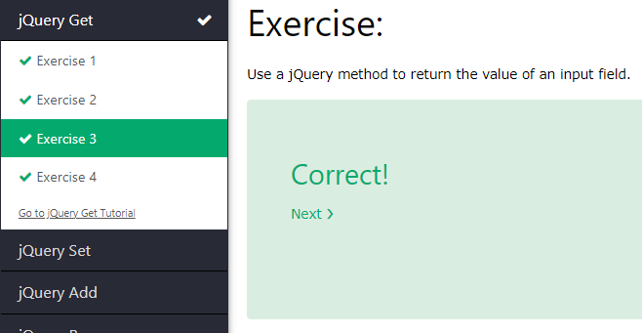

### Exercise 4

Use a jQuery method to return the URL address of a link.

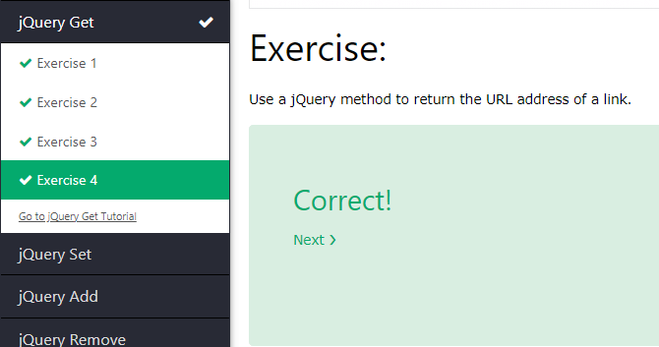

## **JQuery Set**

### Exercise 1

Use a jQuery method to change the text of a <div> element to "Hello World".

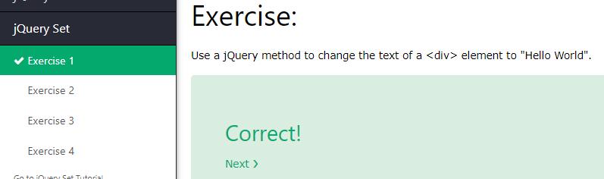

### Exercise 2

Use a jQuery method to change the value of an input field to "John Doe".

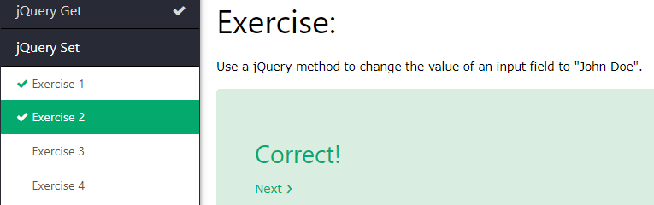

### Exercise 3

Use a jQuery method to change the value of an image's src attribute to "myimage.jpg".

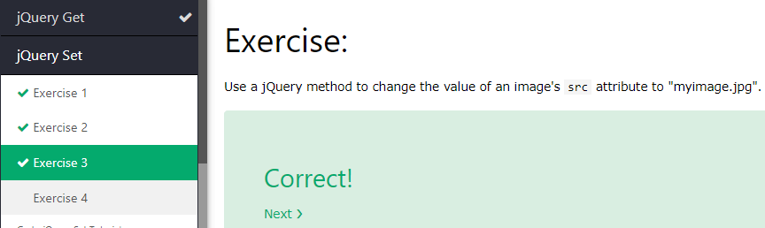

### Exercise 4

Use jQuery to change the text of a link to "Demo", and change the value of href's attribute value to [www.demo.com](http://www.demo.com).

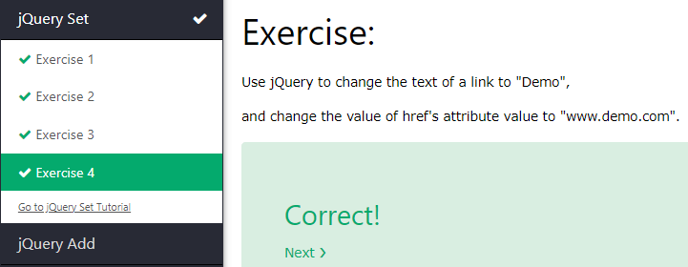

## **JQuery Add**

### Exercise 1

Use a jQuery method to insert the text "YES!" at the end of a <p> element.

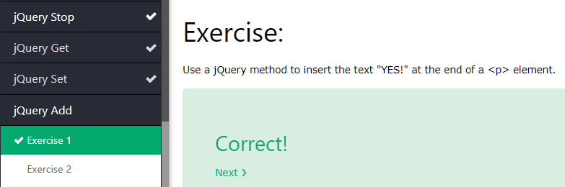

### Exercise 2

Use a jQuery method to insert the text "YES!" at the beginning of a <p> element.

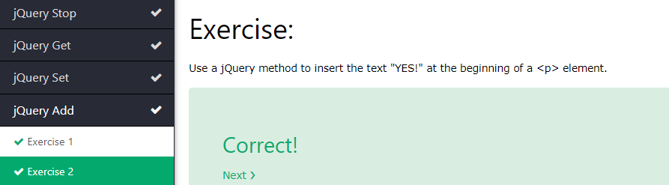

## **JQuery Remove**

### Exercise 1

Use a jQuery method to remove a <div> element.

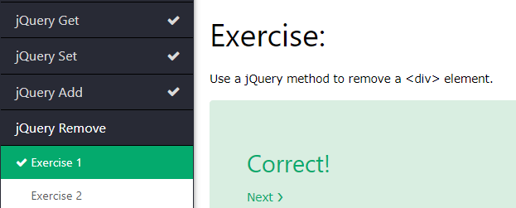

### Exercise 2

Use a jQuery method to only remove the child elements of a <div> element.

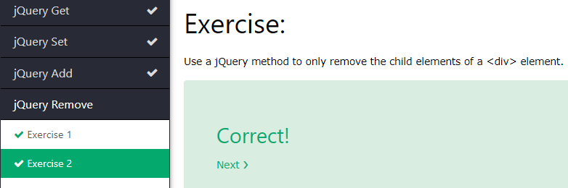

### Exercise 3

Use a jQuery method to remove all <div> elements with class="test" and class="demo".

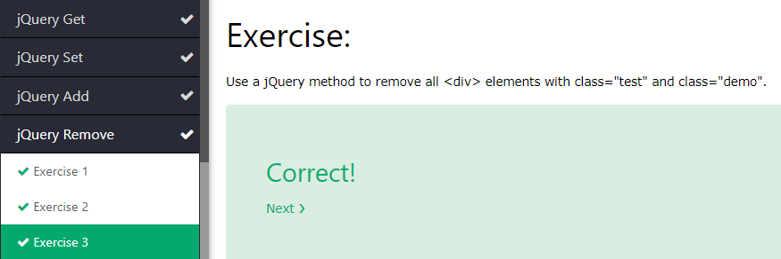

## **JQuery CSS Classes**

### Exercise 1

Use a jQuery method to add the "important" class to a <p> element.

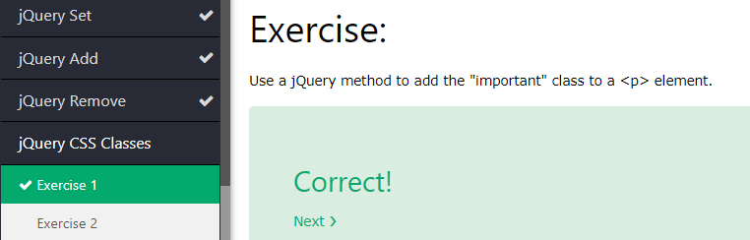

### Exercise 2

Use a jQuery method to add both the "important" and "test" class to a <p> element.

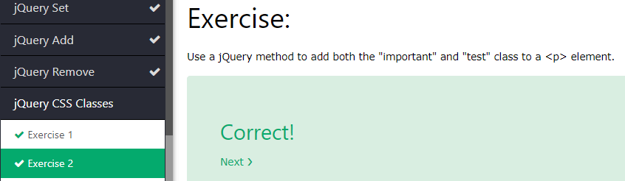

### Exercise 3

Use a jQuery method to remove the "important" class from a <p> element.

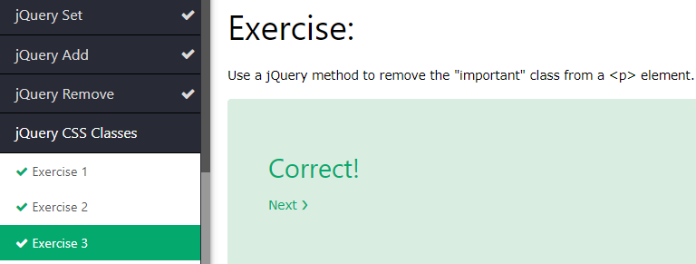

### Exercise 4

Use a jQuery method to toggle between adding and removing the "important" class from the <p> element on click.

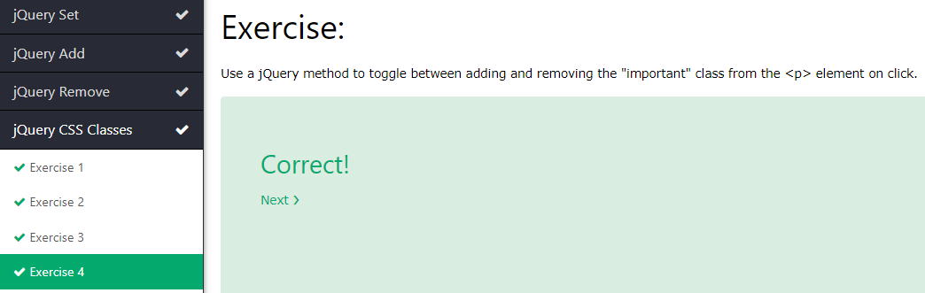

## **JQuery CSS**

### Exercise 1

Use the css() method to add a pink background color to a <p> element.

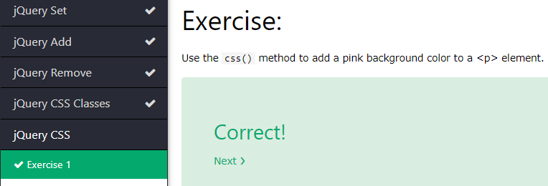

### Exercise 2

Use the css() method to add a 5 pixels red dotted border to a <p> element.

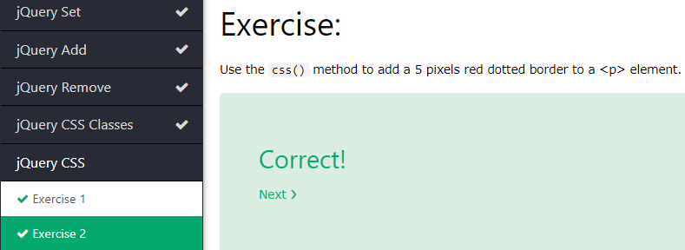

### Exercise 3

Return the background color of a <p> element.

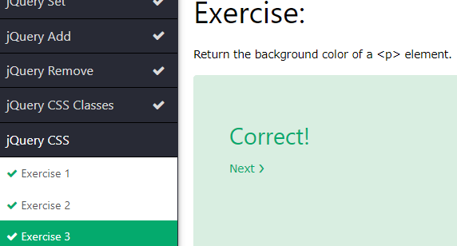

### Exercise 4

Use the css() method to set the following styles for <p> Green background color, white text color, 25 pixels font size and a padding of 15 pixels.

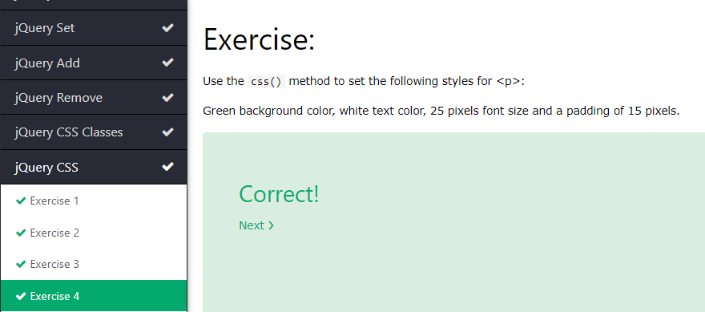

## **JQuery Dimensions**

### Exercise 1

Use jQuery methods to set the height and width of <div> to 500 pixels.

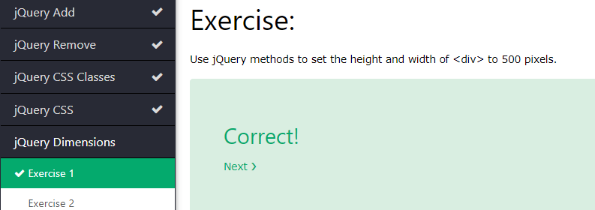

### Exercise 2

Use a jQuery method to get the height of a <div> element, excluding padding, border and margin.

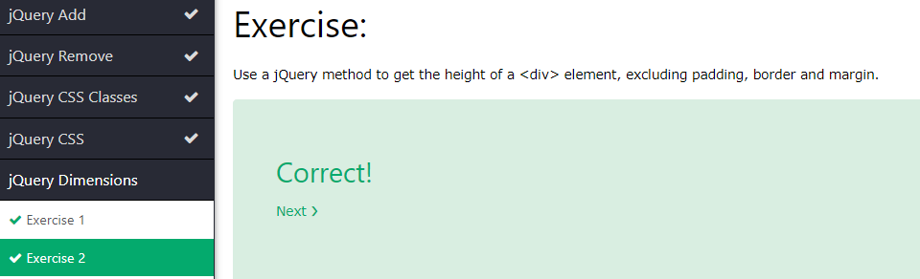

### Exercise 3

Use a jQuery method to get the height of a <div> element, including padding (not border and margin).

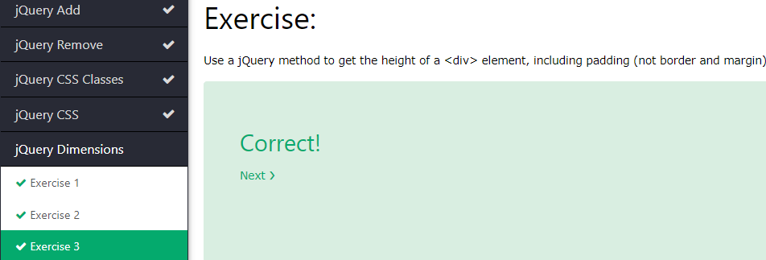

### Exercise 4

Use a jQuery method to get the height of a <div> element, including padding and border.

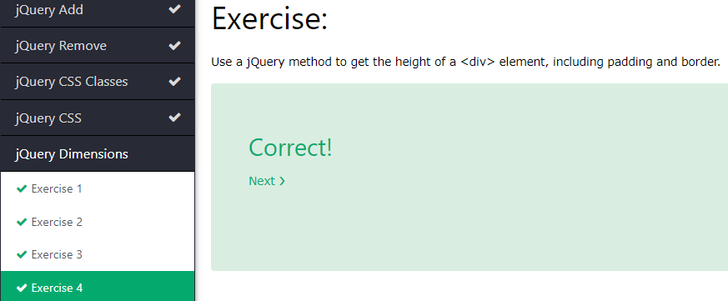

### Exercise 5

Use a jQuery method to get the height of a <div> element, including padding, border and margin.

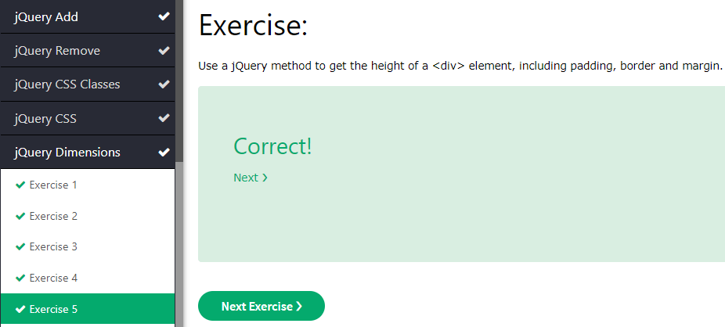

## **JQuery Traversing**

### Exercise 1

Use a jQuery method to get the direct parent of a <span> element.

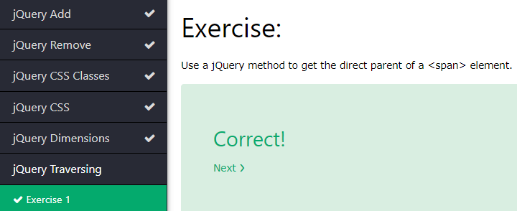

### Exercise 2

Use a jQuery method to get all ancestors of a <span> element.

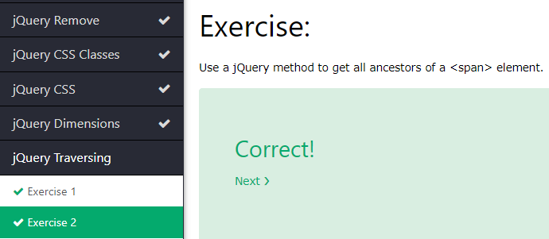

### Exercise 3

Use a jQuery method to get all direct children of a <div> element.

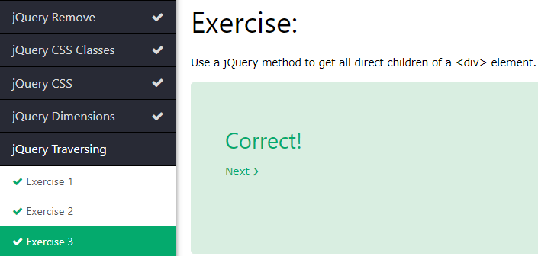

### Exercise 4

Use a jQuery method to get all <span> elements that are descendants of <div>.

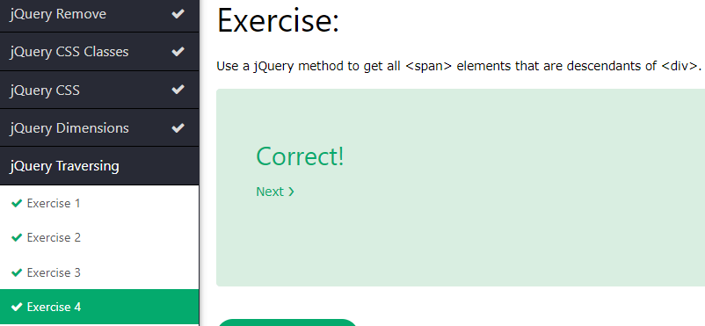

### Exercise 5

Use a jQuery method to get all siblings elements of an <h2> element.

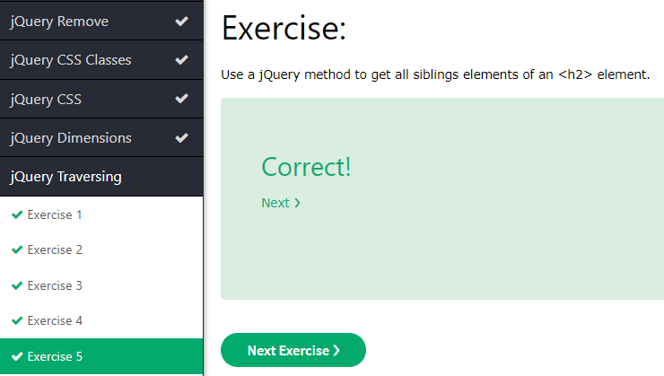

### Exercise 6

Use a jQuery method to get the first <div> element in the document.

